To do list quiz bowl
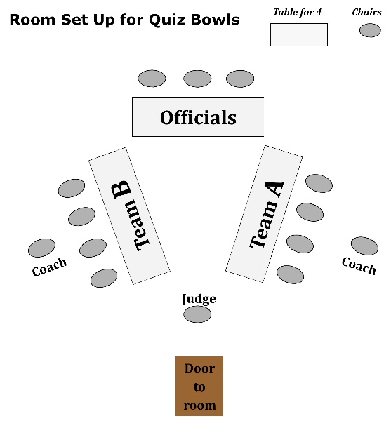
- Reserve rooms
  - Holding room – enough seating for entire registrant list plus parents/coaches
  - Contest rooms – 3 tables and 14 chairs (see picture)

- Secure
  - Buzzer sets (one per contest room plus 2-3 extra)
  - Awards (team and individual if applicable)
  - Food for volunteers/contestants

- Secure appropriate volunteers
  - Identify/select moderators & judges (use last year’s if possible)
  - Solicit volunteers for time keepers
  - Solicit volunteers for score keepers

- Email volunteers instructions (time, location, game instructions, role etc.)

- Email contestants
  - Contest details (time, location, food, etc.)
  - Link to state 4-H quiz bowl rules
  - Academic eligibility reminder
  - Required forms/releases to bring

- Set up bracket on Challonge.com
  - Do bulk of setup before contest (add team names, rename rounds with question set letters)
  - Verify teams upon arrival and do final “shuffle of seed”

- Print materials
Load List
- Snacks/drinks for volunteers
- Awards
- Buzzer sets
- Extension cords & power strips
- Laptops for bracket coordinators (3+)
- Pencils (numerous) and pencil sharpener
- Clipboards (1 per room plus extra)
- Office supplies (binder clips, highlighters, sticky notes, etc.)
- Acrylic paper stands (1 per contest)
- All printed materials
- Official resources in a wagon for transport
  - Question Sets
  - Registration list to check off contestants upon arrival
  - Table tent cards with team names (if applicable)
  - Signs with URL bracket hyperlinks
  - Score Sheets (helpful hint: if running multiple contests/age divisions simultaneously, print score sheets on different colored paper)
  - Bracket Coordinator Sheets
  - Orientation sheets for officials/volunteers
  - Orientation sheets for contestants
  - Labels with seat numbers (2x4)
  - Texas 4-H Quiz Bowl rules
  - Sign “Check-In & Registration” and “Be Quiet”
  - Signs for room numbers (Room 1, 2, 3, 4, etc.)
  - Tent placards for buzzers (A1, B1, etc.)

