National Volunteer Week
April 17-23, 2022

April is National Volunteer Week that is hosted by the Points of Light organization. To participate and capitalize on this timely and relevant week-long event, Texas A&M AgriLife Extension Service and the 4-H Youth Development program will coordinate to promote the volunteer program and its volunteers.

The purpose of this campaign is to highlight the statewide service and achievements of Texas 4-H Youth Development volunteers across the state, recognize impact made in local communities, and generate overall awareness about the volunteer program to attract new potential volunteers.

All Texas A&M AgriLife Extension Service County agents, administrative assistants, program specialists and 4-H Volunteers are encouraged to use the resources in this document to participate during this campaign.

Enclosed you will find:
- Sample news release
- Sample social media posts and graphics
- Sample proclamation

We hope you find this useful to celebrate and recognize your volunteers. Please let us know if you have any questions!
Sample press release

Each year, thousands of 4-H volunteers donate their time and energy to make their communities a better place to live. These volunteers will be among the millions across the country who will be spotlighted during the 48th anniversary of National Volunteer Week, April 17-23, 2022.
This year’s theme for National Volunteer Week is Celebrate Service! It’s an opportunity to shine a light on the people and causes that inspire us to serve. Points of Light, an organization dedicated to volunteer service, states that, “Volunteerism empowers individuals to find their purpose, to take their passion and turn it into meaningful change. When each of us, in our own way, answers the call to make a difference, we make progress in solving our most persistent problems, and create stronger communities and a more just society.”
This week provides us with an opportunity to celebrate the selfless service of our dedicated volunteers and the work they do to help AgriLife Extension identify the communities’ needs and share the educational resources of Texas A&M AgriLife Extension Service. Volunteers involve themselves in programs such as Master Gardeners, Master Naturalists, Master Wellness, 4-H Youth Development, or on local committees focused on the specific areas such as agriculture, natural resources, family and community health, or youth development.
Currently, about 77 million Americans volunteer almost 7 billion hours of their time, talent, and effort to improve and strengthen their communities. With the Value of Volunteer Time ($28.54 per hour) as established by the Independent Sector, these Americans are contributing approximately $187.7 billion to our nation through nonprofit organizations of all types. In 2021, 86,371 Texas A&M AgriLife Extension Service Volunteers contributed 4,294,267 hours of service valued at $122,55.378. The Texas 4-H Youth Development Program relies heavily on the work of volunteers. In 2021, more than 18,000 adult and youth volunteers contributed countless hours in various capacities to the 4-H youth in their Texas communities.
In [Insert County], [total number] volunteers, both youth and adult, will serve as club leaders, project leaders, committee members, and in advisory capacities for the 4-H Youth Development Program in 2021.
[Add quote from County Extension Agent about impact of volunteers to the county Extension program.]
AgriLife Extension volunteers spend numerous hours working on tasks, such as leading educational programs, providing guidance and ideas regarding community needs, maintaining gardens, helping organize events at the county fair, helping a child with a 4-H project, or leading a project to serve the community. [update with specific tasks and Extension volunteers conduct in your county]
[Add quote from an Extension volunteer.]
AgriLife Extension volunteers are just one group of volunteers who are instrumental in carrying out the mission of the Texas A&M AgriLife Extension Service. Volunteers are involved in every aspect of the Extension Service, including determining the needs of the local residents, planning and implementing programs to address these needs, securing resources, and evaluating programs. Thank you, to all AgriLife Extension volunteers for the impact you make on the people and communities around you.

###

Social media

Facebook profile photo frame:
https://www.canva.com/design/DAE-NsjQ3-s/2VhsGcbD1sRTJHFPuO_uDw/view?utm_content=DAE-NsjQ3-s&utm_campaign=designshare&utm_medium=link&utm_source=publishsharelink&mode=preview

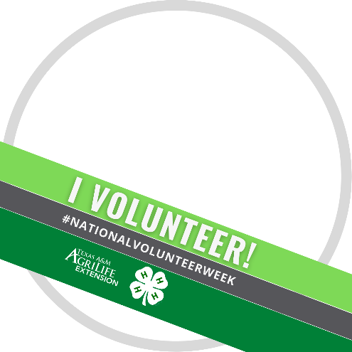
Graphic templates available here:
https://www.canva.com/design/DAE-NdAvPus/ajgKYaAIvtXbU7Fte4IeoA/view?utm_content=DAE-NdAvPus&utm_campaign=designshare&utm_medium=link&utm_source=publishsharelink&mode=preview
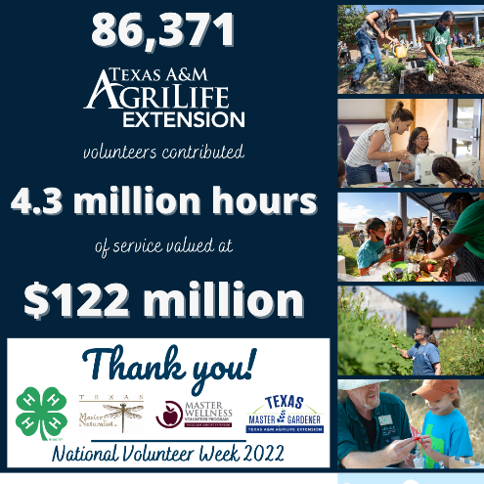
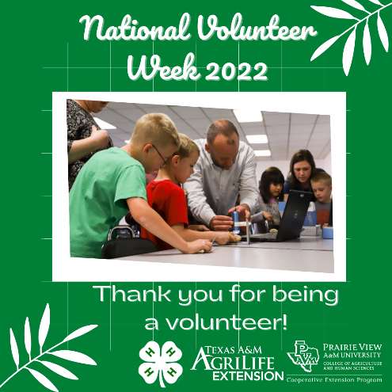
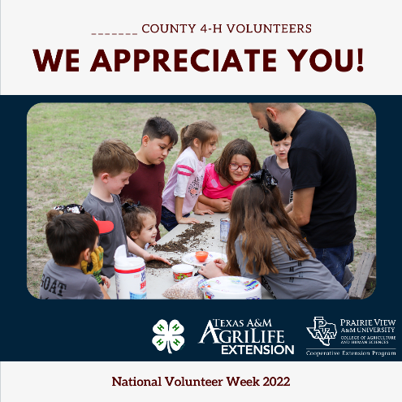

Facebook & Instagram

- We are celebrating #NationalVolunteerWeek throughout April! Volunteers are the heart of communities across Texas. Their selfless service, dedication and continuous hard work makes an impact every day. We thank you for your devotion to the @Texas4H Youth Development program, your community and Texans everywhere. @AgriLifeExtension

- Join us as we celebrate #NationalVolunteerWeek! Volunteerism helps create better communities. @Texas4H Youth Development volunteers across the state are committed to providing education and life skill development for our young Texans. Tag a 4-H volunteer you know! @AgriLifeExtension

- What does volunteering mean to you? During #NationalVolunteerWeek we celebrate the @Texas4H volunteers who connect with and educate youth to help them grow into productive adult through project and learning experiences. Our 4-H volunteers truly make a difference in lives of youth! @AgriLifeExtension

- It’s #NationalVolunteerWeek! We’re sharing how our @Texas4H Youth Development Volunteers serve in counties and the impact they make. Want to make a difference in your community? Visit (website here) to learn more! @AgriLifeExtension

- #NationalVolunteerWeek is an opportunity to celebrate the impact of volunteer service and the power of volunteer to come together to tackle tough challenges, and build stronger, more resilient communities! Thank your local @Texas4H and @AgriLifeExtension volunteers this week!

- During #NationalVolunteerWeek, @Texas4H and @AgriLifeExtension celebrate the power of volunteers to make a difference and recognize extraordinary individuals who are at the center of 4-H success. Thank a 4-H volunteer who made a difference in your life!

Twitter:
- It’s #NationalVolunteerWeek! This week, we are highlighting the service and impact our @Texas4H volunteers have in (name of county) through education and outreach. Stay tuned for more! #AgriLifeExtension
- Celebrate service during #NationalVolunteerWeek! Volunteerism brings @Texas4H together to tackle society’s tough challenges, spark change, and build stronger, more resilient youth! #AgriLifeExtension

Sample Proclamation

- WHEREAS, volunteering of one's time and resources is a fundamental part of our country’s tradition and is essential to its spirit, and;
- WHEREAS, it is increasingly more evident that our nation's greatest resource is its people, and;
- WHEREAS, volunteers have shown that they truly care and share generously of themselves, and;
- WHEREAS, volunteerism is increasingly recognized as a central partner with government, education, and industry in doing the work of our nation, and;
- WHEREAS, volunteers in the ___________ County 4-H program enable youth of ____________ County to more fully develop and utilize their life skills, effectively use their resources, and more fully extend the knowledge of the university to the people, and;
- WHEREAS, volunteerism directly reflects the democratic principles upon which this nation was founded in that everyone, regardless of circumstance, position, or other factors can volunteer, and;
- WHEREAS, we are seeking even more contributions of human resources in volunteerism and better application of these valuable contributions:
- THEREFORE, we wish to honor and to thank the dedicated 4-H Volunteers of ___________ County who give so freely of their valuable time, energy and abilities by proclaiming this week of April 17-23, 2022, to be officially designated as National Volunteer Week in ______________ County.
- And in doing so, I call all citizens of __________ County to help renew and sustain the spirit and vitality of this great nation by committing a portion of their time to address the needs of their communities through voluntary action.

Signed this _______ day of _________, 2022 by

_______________________________
(Name of County Official)

_______________________________
(Position)

